# Problem Set 3: Graphics

#### Prateek Kumar

# 1. Dotchart Function

# I have set the figure dimension as a global option

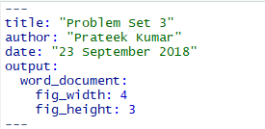

Figure 1: I am setting 4X3 because I have interchanged my plot’s x and y axis for Q1

set.seed(100)  
data2 <- data.frame(q1=sample(letters[1:10],100,replace=T), #The given dataset to test  
 q2=sample(letters[1:10],100,replace=T),  
 q3=sample(letters[1:10],100,replace=T),  
 q4=sample(letters[1:10],100,replace=T),   
 q5=sample(letters[1:10],100,replace=T))  
  
datatable2<-apply(data2,2,table)  
  
# A new dotchart function mydotchart()  
mydotchart <- function(data,labels=NULL, colors = 1:5, main = "Displaying the Dot chart", xlab = "Letters", ylab = "Number of Letters", xlim = c(0, 13), ylim = c(0, 20), lty = 1, normalize=F,col, pch = 15, cex = 1,subsets)  
 {  
 # Checking if we want to normalize the data  
 if (normalize)   
 {  
 data <- (data - min(data))/(max(data)-min(data)) # Data normalized  
 # Plotting the dotchart  
 matplot(1:nrow(data), data , pch = pch, xlim = xlim, ylim = c(0,1), col = colors, xaxt="n", main = main, xlab = xlab, ylab = ylab, lty = lty, cex = cex, type='b')  
   
 axis(1,1:nrow(data),letters[1:10],las=1) # Setting the x-axis as the parameters  
   
 # Drawing the segments  
 segments( 1:10, 0, 1:10, 10, lty = 3)   
 segments( x0=1, y0=c(0,0.1,0.2,0.3,0.4,0.5,0.6,0.7,0.8,0.9,1), x1=10, y1=c(0,0.1,0.2,0.3,0.4,0.5,0.6,0.7,0.8,0.9,1), lty = 3)  
   
 # Drawing the legend  
 legend(11,1, legend = colnames(data), col = 1:5, fill = 1:5, cex = 0.6, title="Line types", bg='grey')  
 }  
 else  
 {  
 # If we do not want to normalize, plotting the dotchart as per the data  
 matplot(1:nrow(data), data , pch = pch, xlim = xlim, ylim = ylim, col = colors, xaxt="n", main = main, xlab = xlab, ylab = ylab, lty = lty, cex = cex, type='b')  
   
 axis(1,1:nrow(data),letters[1:10],las=1) # Setting the x-axis as the parameters  
   
 # Drawing the segments  
 segments( 1:10, 0, 1:10, 20, lty = 3)  
 segments( x0=1, y0=0:20, x1=10, y1=0:20, lty = 3)  
   
 # Drawing the legend  
 legend(11,20, legend = colnames(data), col = 1:5, fill = 1:5, cex = 0.6, title="Line types", bg='grey')   
 }  
   
}

* The above is the dotchart function based on the matplot version we did in class. The function name is mydotchart(). The function has arguments like data, colors, main etc. which helps to customize the dotchart as per the user. Here I have set the default parameters for some of the values incase the user does not pass those arguments the dotchart will be plotted based upon those values.
* Here we have tested the dotchart plotting based upon the data frame “datatable2”.
* When we see the set of arguments in the function, there is an argument “normalize”. We are setting the value to False as default and when the user wants to normalize the data he/she can just call the mydotchart() function passing the normalize argument as True. Now what normalize does? Normalize adjusts the value on different scale to a common scale, here it is setting the values between 0 to 1.
* Now the meaning of the arguments passed:

1. data: The dataset on which we want to plot the dotchart
2. labels: Inorder to create our own value labels
3. colors: Setting the colors in the plot
4. main: Display the plot title
5. xlab: Names of the x-axis
6. ylab: Names of the y-axis
7. xlim: Setting the limit of x-axis
8. ylim: Setting the limit of y-axis
9. lty: Setting the line type in the plot
10. normalize: Contains the boolean value T/F if we want to normalize the data or not
11. col: Setting the plotting color
12. pch: Setting the point shape in the plot
13. cex: Scaling the plot
14. subsets: Inorder to subset the data

mydotchart(datatable2)

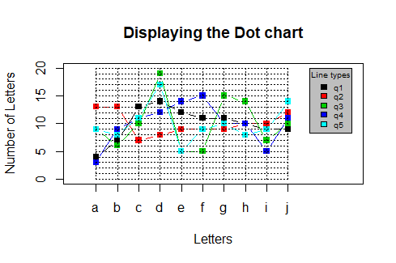

Figure 2: Here we just plot the dotchart on the dataset 'datatable2'

mydotchart(datatable2[,1:2])

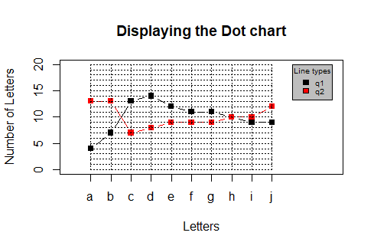

Figure 3: Here we plot the dotchart on the first 2 columns of the dataset 'datatable2'

mydotchart(datatable2[,1])



Figure 4: Here we get the error because data is interpreted as a vector

mydotchart(as.matrix(datatable2[,1]))

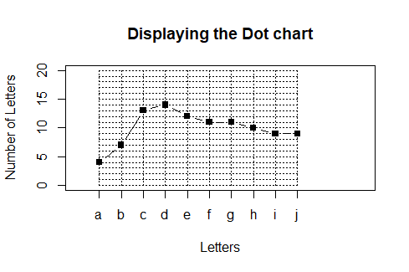

Figure 5: Here we get the plot without the legend



Figure 6: The error because the length of legend is zero

mydotchart(datatable2[,1:3])

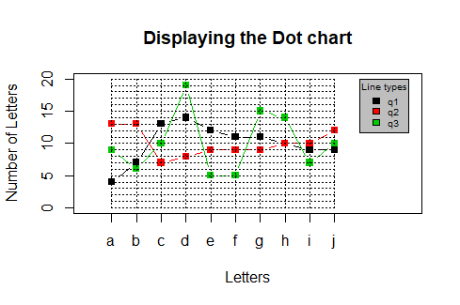

Figure 7: Here we plot the dotchart on the first 3 columns of the dataset 'datatable2'

mydotchart(datatable2,col=1:5)



Figure 8: Here we plot the dotchart on the first 5 columns of the dataset 'datatable2'

mydotchart(datatable2,col=1:5,pch=16)

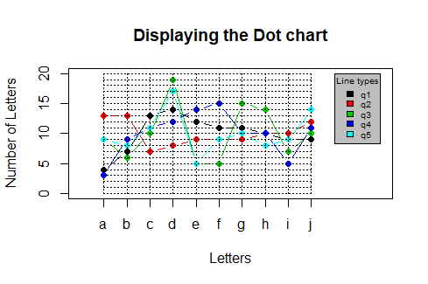

Figure 9: Here we just plot the dotchart on the dataset 'datatable2' with color and pch value

mydotchart(datatable2,col=1:5,pch=16,cex=2.5,main="Everything",xlab="Value", ylab="Category")

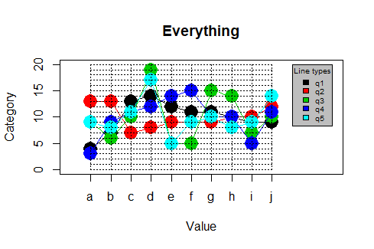

Figure 10: This is same as fig 9 with cex, main, xlab and ylab values

mydotchart(datatable2,col=1:5,pch=16,cex=2.5,main="Everything normalized",xlab="Value", ylab="Category", normalize=T)

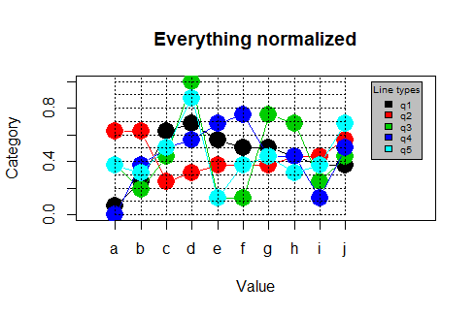

Figure 11: This is same as fig 10 but the data is normalized

# 

# 2. Correlating word frequency with SCRABBLE scores

# Frequency of each letter  
lf <- c(8.167,1.492,2.782,4.253,12.702,2.228,2.015,6.094,  
 6.966,0.153,0.772,4.025,2.406,6.749,7.507,1.929,  
 0.095,5.987,6.327,9.056,2.758,0.978,2.36,0.15,1.974,0.074)/100  
  
# Points earned in Scrabble  
pts <- c(1,3,3,2,1,4,2,4,1,8,5,1,3,1,1,3,10,1,1,1,1,4,4,8,4,10)  
  
# Number of Scrabble tiles  
tiles <- c(9,2,2,4,12,2,3,2,9,1,1,4,2,6,8,2,1,6,4,6,4,2,2,1,2,1)  
  
#Creating the data frame of the four values  
lf.table <- data.frame(LETTERS, freq=lf, points=pts, ntiles=tiles)

This function computes the sum of the inverse letter frequency of the letters, the total scrabble points, the mean numbers of tiles of the letters in the word, and the length of the word

scoreme <- function(word)  
{  
   
 lets <- strsplit(splus2R::upperCase(word),"")[[1]]  
 data <- matrix(0,ncol=4,nrow=length(lets))  
   
 for(i in 1:length(lets))  
 {  
 index <- which(lets[i]==LETTERS)  
 data[i,1] <- lf.table$freq[index]   
 data[i,2] <- lf.table$points[index]  
 data[i,3] <- lf.table$ntiles[index]  
   
 }   
 list(suminvfreq= sum(1/data[,1]),  
 points=sum(data[,2]),  
 meantiles=mean(data[,3]),  
 length=length(lets))  
}

The following lists a set of words, along with their rank frequency (lower meaning more frequent), and their total frequency (number of occurrences in a large corpus)

test <- read.table(text='rank word frequency  
 1081 CUP 1441306  
 2310 FOUND 573305  
 5285 BUTTERFLY 171410  
 7371 brew 94904   
 11821 CUMBERSOME 39698  
 17331 useable 17790   
 18526 WHITTLE 15315  
 25416 SPINY 7207  
 27381 uppercase 5959  
 37281 halfnaked 2459  
 47381 bellhop 1106   
 57351 tetherball 425  
 7309 attic 2711   
 17311 tearful 542   
 27303 tailgate 198   
 37310 hydraulically 78   
 47309 unsparing 35   
 57309 embryogenesis 22 ', header=T, stringsAsFactors=FALSE)[,c(2,1,3)]

We add four columns into the data frame for the four statistics value: sum of the inverse letter frequency of the letters, the total scrabble points, the mean numbers of tiles of the letters in the word, and the length of the word

test$meantiles <- NA  
test$suminvfreq <- NA  
test$points <- NA  
test$length <- NA

We now populate the four statistics value into the table

for(i in 1:nrow(test))  
 {  
 temp<-scoreme(test[i,1])  
 test[i,5] <- temp[1]  
 test[i,6] <- temp[2]  
 test[i,4] <- temp[3]  
 test[i,7] <- temp[4]  
}

We now plot the values

par(mfrow=c(1,2)) # we are showing plots with one statistic value for each rank and frequency

plot(test$rank,test$meantiles,xlab = 'Rank', ylab = 'Meantiles',pch=16, main = paste('Rank vs Meantiles\nCor =',round(cor(test$rank,test$meantiles),3)))  
  
plot(test$frequency,test$meantiles, xlab = 'Frequency', ylab = 'Meantiles', xlim = c(0,10000), pch=16, main = paste('Frequency vs Meantiles\nCor =',round(cor(test$frequency,test$meantiles),3)))

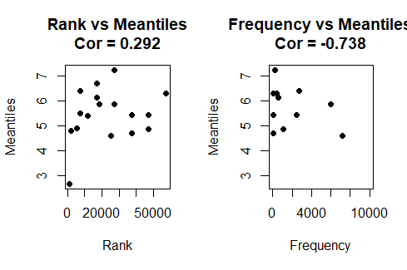

Figure 12: Rank and frequency vs the mean numbers of tiles of the letters in the word

plot(test$rank,test$suminvfreq, xlab = 'Rank', ylab = 'Suminvfreq',pch=16, main = paste('Rank vs Suminvfreq\nCor =',round(cor(test$rank,test$suminvfreq),3)))  
  
plot(test$frequency,test$suminvfreq, xlab = 'Frequency', ylab = 'Suminvfreq', xlim = c(0,10000), pch=16, main = paste('Frequency vs Suminvfreq\nCor =',round(cor(test$frequency,test$suminvfreq),3)))

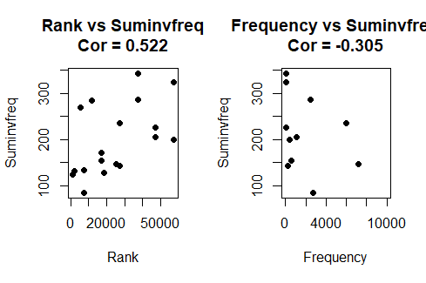

Figure 13: Rank and frequency vs the sum of the inverse letter frequency of the letters

plot(test$rank,test$points, xlab = 'Rank', ylab = 'Points',pch=16, main = paste('Rank vs Points\nCor =',round(cor(test$rank,test$points),3)))  
  
plot(test$frequency,test$points, xlab = 'Frequency', ylab = 'Points', xlim = c(0,10000),pch=16, main = paste('Frequency vs Points\nCor =',round(cor(test$frequency,test$points),3)))

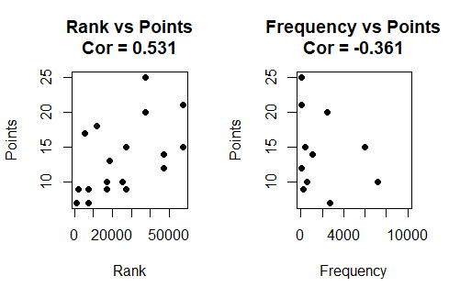

Figure 14: Rank and frequency vs the total scrabble points

plot(test$rank,test$length, xlab = 'Rank', ylab = 'Length',pch=16, main = paste('Rank vs Length\nCor =',round(cor(test$rank,test$length),3)))  
  
plot(test$frequency,test$length, xlab = 'Frequency', ylab = 'Length', xlim = c(0,10000),pch=16, main = paste('Frequency vs Length\nCor =',round(cor(test$frequency,test$length),3)))

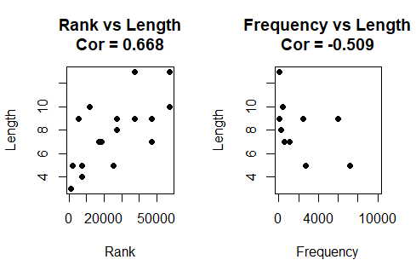

Figure 15: Rank and frequency vs length of the word

* Negative correlation is a relationship between two variables in which one variable increases as the other decreases, and vice versa and positive correlation exists when one variable decreases as the other variable decreases, or one variable increases while the other increases.
* In the above plots we see that all the four statistics values are positively correlated with rank and are in negative correlation with frequency.

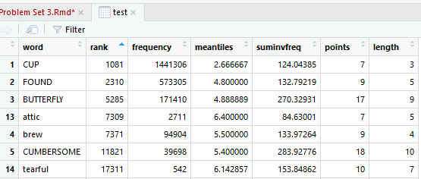

Figure 16: Looking at the table we can say that rank is positively correlated with all the four statistics value i.e. when rank increases the values tend to increase.

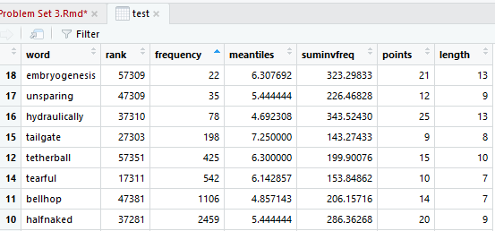

Figure 17: When we check the values with frequency we see that they are negatively correlated i.e. when the frequency increase the values tend to decrease.

* Rank frequency gives an idea that how much is the word frequent in general, the lower the value the more frequent the word, and total frequency is the number of occurrences of the word in a large corpus. By looking at rank frequency we can identify that how frequent is the word and the total frequency is relevant to a particular collection of written or spoken material, so it specifies the occurrence of a word in that corpus.
* This does not signify that if rank frequency is lower than the raw frequency will be high. As said earlier that raw frequency depends on a particular corpus, so there might be a possibility that a particular word has less rank frequency and also has less raw frequency. E.g. In our table test the word ‘attic’ signifies this. So we can say that a higher correlation is not always meaningful.
* Note that correlation does not suggest causality. E.g. Let’s consider the correlation between sales of ice-cream in summer and increment in petroleum costs. Obviously, both are not related but rather we will get a positive correlation here because both the values are increasing. So it is additionally critical to note that the correlation coefficient just estimates linear relationships. A meaningful *nonlinear*relationship may exist regardless of whether the correlation coefficient is 0.